**What is Apache Airflow?**

Apache Airflow is a powerful, open-source platform designed to programmatically author, schedule, and monitor workflows. At its core, Airflow allows you to define complex data pipelines as code, bringing the principles of software engineering—such as version control, testing, and collaboration—to the world of data engineering.

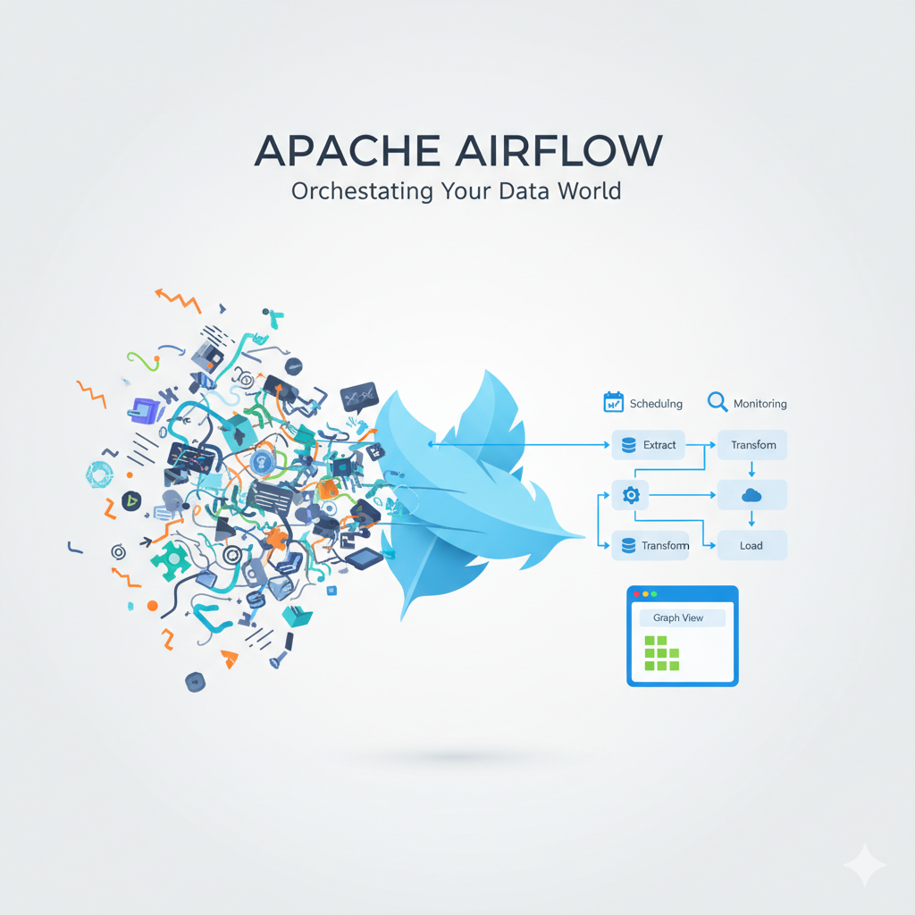

**Core Concepts**

To understand Airflow, it's essential to grasp its fundamental building blocks:

* **DAGs (Directed Acyclic Graphs):** A DAG is the centerpiece of Airflow. It is a collection of all the tasks you want to run, organized in a way that reflects their relationships and dependencies. The "Directed Acyclic" nature means that data and processes flow in one direction without any circular loops. Each DAG represents a single, complete workflow. For example, a simple ETL (Extract, Transform, Load) process can be represented as a DAG.
* **Tasks:** A task is a single unit of work within a DAG. It is an instance of an Operator and represents a specific action to be performed, such as running a script, executing a SQL query, or sending an email.
* **Operators:** Operators are pre-built templates that serve as the building blocks for your tasks. Airflow comes with a vast library of operators, and you can also create your own. Common operators include:
  + BashOperator: Executes a bash command.
  + PythonOperator: Calls an arbitrary Python function.
* **Key Architectural Components:**
  + **Web Server:** Provides a rich user interface to visualize your pipelines, monitor their progress, view logs, and manually trigger or debug tasks.
  + **Scheduler:** This is the heart of Airflow. It is a persistent service that monitors all of your DAGs, checks their schedules, and submits the necessary tasks to the executor to be run.
  + **Metadata Database:** This database (typically PostgreSQL or MySQL) stores the state of all your workflows, task instances, configurations, and user information. The Scheduler and Web Server both interact with this database to stay in sync.

**Why Apache Airflow**

**Key Reasons to Adopt Airflow**

1. **To Automate and Schedule Complex Data Pipelines** The most common use case for Airflow is orchestrating ETL/ELT (Extract, Transform, Load) processes. Airflow excels at managing intricate dependencies between tasks. For example, a task to generate a report will not run until the upstream tasks—such as extracting data from an API and cleaning it in a database—have completed successfully. This dependency management ensures data integrity and process correctness, moving beyond simple time-based scheduling (cron) to dependency-based execution.
2. **For Robust Monitoring and Alerting** Without a proper orchestrator, it's difficult to know the status of your data processes. Airflow's web interface provides a centralized "single pane of glass" to monitor all your workflows. You can:
   * **Visualize Pipelines:** See your DAGs as graphs, track the status of each task (running, success, failed, skipped), and identify bottlenecks.
   * **Access Logs:** Immediately access detailed logs for every task run directly from the UI, making debugging significantly faster.
   * **Configure Alerts:** Set up automatic alerts via email, Slack, or other platforms to be notified the moment a task fails, enabling your team to respond quickly and minimize downtime.
3. **To Standardize and Scale Your Workflows** Airflow’s "Workflows as Code" paradigm is a game-changer. By defining your data pipelines in Python, you unlock several key benefits:
   * **Version Control:** Store your DAGs in a version control system like Git. This allows you to track changes, collaborate with team members, review code, and roll back to previous versions if needed.
   * **Dynamic Pipelines:** Since your workflows are code, you can generate them dynamically. This means you can create flexible and reusable pipelines that adapt to changing conditions, such as creating a new DAG for each new table or client that is added.
   * **Scalability:** Airflow's modular architecture is built to scale. As your data volume and the number of workflows increase, you can scale out your Airflow environment by adding more worker nodes to handle the increased load, ensuring your system remains performant.

**Key Advantages**

1. **Dynamic, Extensible, and Flexible** Because Airflow DAGs are written in Python, the platform is incredibly flexible. Essentially, if you can write it in Python, you can run it in Airflow. This allows for the creation of highly dynamic and sophisticated workflows. Furthermore, Airflow is highly extensible. If a pre-built operator doesn't exist for your specific system or use case, you can easily create your own custom Operators, Hooks, and Plugins. This adaptability allows Airflow to integrate seamlessly into any existing tech stack.
2. **Rich User Interface and Observability** The Airflow UI is a powerful tool for managing and understanding your workflows. It provides multiple views to inspect your pipelines, such as a Graph View to see dependencies, a Gantt Chart to visualize task duration over time, and a Task Instances view to see the status of all past runs. This high level of observability provides complete transparency into your data processes, making it easy for anyone on the team to understand what’s happening, what succeeded, and what failed.
3. **Robust Error Handling and Recovery** In the real world, systems fail. Airflow is built with this reality in mind. It provides several mechanisms for handling failures gracefully:
   * **Automatic Retries:** You can configure tasks to automatically retry a specified number of times if they fail, which can often resolve transient issues (like a temporary network outage) without any manual intervention.
   * **Backfilling:** Airflow makes it simple to re-run your pipelines for historical dates. If you need to reprocess data from the last month due to a bug fix, you can do so with a single command.
   * **Clear Failure States:** The UI clearly marks failed tasks, allowing you to quickly identify the point of failure, debug using the available logs, and manually clear the task to have it re-run.
4. **Vibrant Open-Source Community and Ecosystem** As a top-level Apache project, Airflow is backed by a large and active global community of developers and users. This results in:
   * **Continuous Improvement:** The platform is constantly being updated with new features, performance enhancements, and security patches.
   * **Extensive Integrations:** The community has built a massive ecosystem of "provider packages" that offer out-of-the-box integrations with hundreds of third-party services, including cloud platforms (AWS, Google Cloud, Azure), databases (Snowflake, BigQuery), and data processing tools (Spark, Databricks).
   * **Excellent Support:** With a vibrant community comes a wealth of public documentation, tutorials, articles, and forums where you can find answers to questions and learn best practices.